Group Members Names _________________________________
Phases and Phase Diagrams
Activity I: Phases and Solid Solution Binary Alloys
- A glass of water has sugar slowly added to it until it saturates and a small amount of sugar is left at the bottom. A small amount of extra sugar is then added to the system and students are asked to predict what will happen to the sugar. Student A says, “A little bit more of the sugar can now dissolve in the water, but the majority of the sugar will settle to the bottom.” Students B says, “No more sugar can dissolve in the water unless you stir it.” Student C says, “The solution is super-saturated. No more sugar can dissolve even if you stir.” Which student’s statement is the most correct? Explain.

- a) For each point draw the microstructure.
A B

C D

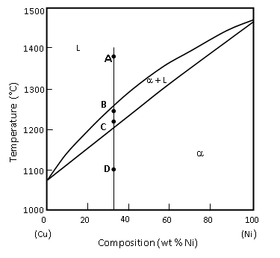
b) Is the % wt composition of Ni in the alpha phase the same for pt B and C? Explain

Activity II: Binary Eutectic Alloys
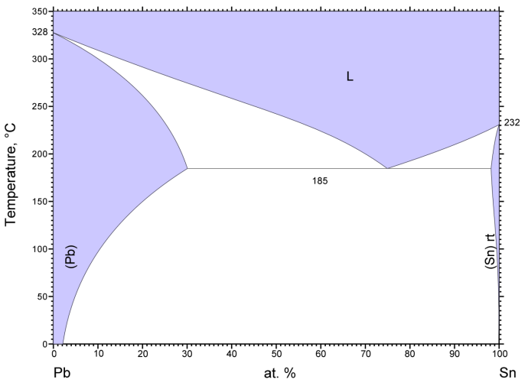
- Some binary alloys (alloys with two constituents) have only one solid phase such, as the Copper-Nickel system. Others have two solid phases, such as the Lead-Tin system.

- Why is this?

- Under what conditions will a Lead Tin alloy have only one phase?

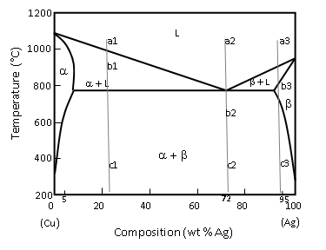
- Draw pictures of the microstructure of this Copper-Silver alloy as you slowly cool the solution.
At 97% Ag
a3: b3: c3:

At 72% Ag
a2: b2: c2:

At 24% Ag

a1: b1: c1:

Activity III: Using the Phase Diagram to Determine Phase Composition and Amounts.
- At point b1 in the above diagram, estimate the composition of the α?

- At point b1 in the above diagram, estimate the composition of the Liquid?

- At point b1 in the above diagram, use your estimates above to calculate the fraction of the microstructure that is α?

- At point b1 in the above diagram, use your estimates above to calculate the fraction of the microstructure that is Liquid?

Activity IV: Looking Backward
- When water is at a certain temperature, a small change to the temperature is all that is needed to go from all solid to all liquid. Does the same thing happen to binary alloys? Explain.

- In the Cu-Ag eutectic phase diagram on page 2, what is alpha? Draw a picture of alpha at the atomic level.

- What is the difference between phase composition and phase fraction?

