Group Member Names _________________________________
Properties of Crystals and Defects
Pre Activity

1. Material A has a smaller average atomic separation than Material B, i.e. the atoms in Material A are on
average closer together. Which of the following statements is true?
a) Material A has greater mass density.
b) Material B has greater mass density.
c) Material A or Material B could have the greater mass density.

Activity I: Crystals & Atomic Packing Factor

- Give an explanation of the atomic packing factor which another student who has never had materials
science would understand.

- Draw a body-centered cubic (BCC) unit cell.

- Determine the relation between the length of a side of the unit cell, a, and the radius of the atoms, r.

- Using your relation between a and r find the atomic packing factor for a bcc unit cell.
Hints: atomic packing factor = Volume of atoms in a unit cell / Volume of a unit cell.
Volume of atoms = Number of atoms*4/3 π r³

- Imagine that you fill this room with close-packed basketballs. Then you fill the room with close-packed marbles. How does the amount of empty space in the room when it is filled with basketballs compare to that when it is filled with marbles?

Activity II: Point Defects.
- “Sketch” each defect and then briefly describe each defect and where it could occur in the unit cell.

Sketch of each defect at an atomic level | Written description for each defect & where it can occur
Vacancy:  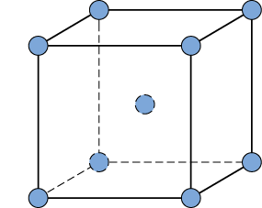 | Description:  Occurs:

Sketch of each defect at an atomic level | Written description for each defect & where it can occur
Self Interstitial: | Description:  Occurs:
Interstitial Impurity: | Description:  Occurs:

Activity III: Looking Forward/Challenge Questions

- A crystal structure looks different from different angles, and behaves differently depending on its orientation. (Try to picture this mentally or draw a BCC structure to help you visualize it.) If a metal is polycrystalline, how can the metal’s properties be non-directional? Can a polycrystalline metal be directional in its properties?

Post Activity

9. Material A has a greater mass density than Material B. Which of the following statements is true?
a) Material A has smaller average atomic separation.
b) Material B has smaller average atomic separation.
c) Material A or Material B could have smaller average atomic separation.

Explain your reasoning:

